**<https://docs.microsoft.com/en-in/learn/modules/choose-storage-approach-in-azure/>**

**ProductID Name Description Image**

**1 TShirt Desc1**

**2 Trouser Desc2**

**3 Shoe Desc3 BlueToothEnabled**

**List of the Different NoSQL Databases**

* MongoDB. MongoDB is the most widely used document-based database. ...
* Cassandra. Cassandra is an open-source, distributed database system that was initially built by Facebook (and motivated by Google's Big Table). ...
* ElasticSearch. ...
* Amazon DynamoDB. ...
* HBase.

[**https://www.w3schools.in/mongodb/environment-setup/**](https://www.w3schools.in/mongodb/environment-setup/)

(<http://www.mongodb.org/downloads>)

<https://www.mongodb.com/try/download/community>

**Introduction to NoSQL**

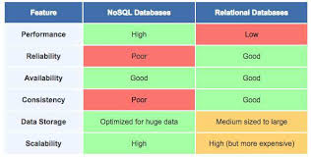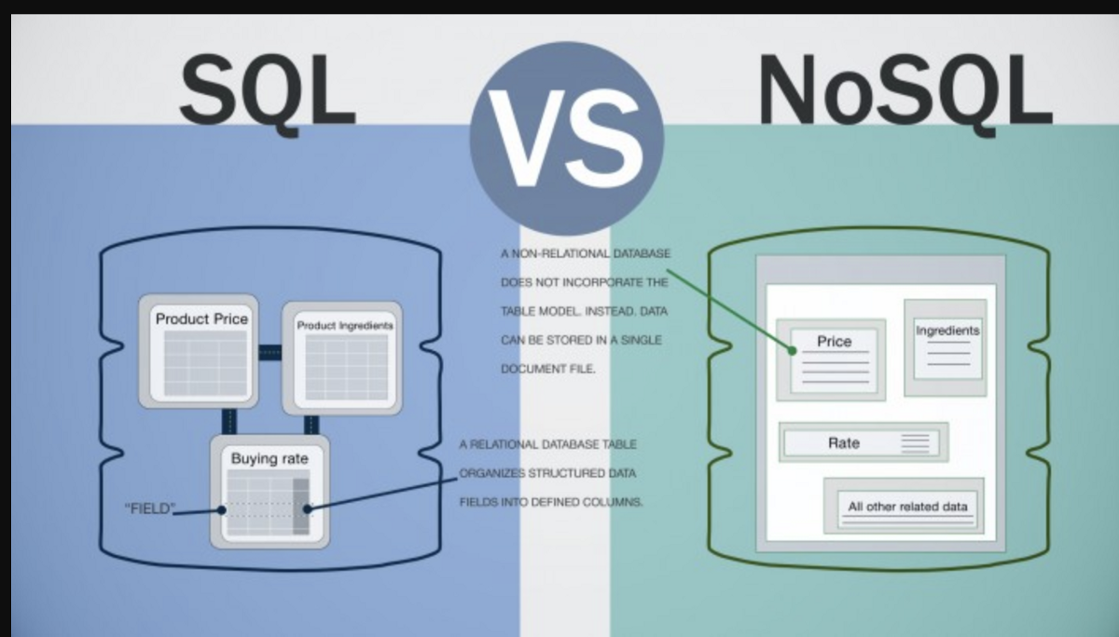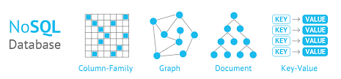

A **NoSQL** originally referring to non SQL or non relational is a database that provides a mechanism for storage and retrieval of data. This data is modeled in means other than the tabular relations used in relational databases. Such databases came into existence in the late 1960s, but did not obtain the NoSQL moniker until a surge of popularity in the early twenty-first century. NoSQL databases are used in real-time web applications and big data and their use are increasing over time. NoSQL systems are also sometimes called Not only SQL to emphasize the fact that they may support SQL-like query languages.

A NoSQL database includes simplicity of design, simpler horizontal scaling to clusters of machines and finer control over availability. The data structures used by NoSQL databases are different from those used by default in relational databases which makes some operations faster in NoSQL. The suitability of a given NoSQL database depends on the problem it should solve. Data structures used by NoSQL databases are sometimes also viewed as more flexible than relational database tables.

Most NoSQL stores lack true ACID(Atomicity, Consistency, Isolation, Durability) transactions but a few databases, such as MarkLogic, Aerospike, FairCom c-treeACE, Google Spanner (though technically a NewSQL database), Symas LMDB, and OrientDB have made them central to their designs.

Most NoSQL databases offer a concept of eventual consistency in which database changes are propagated to all nodes so queries for data might not return updated data immediately or might result in reading data that is not accurate which is a problem known as stale reads. Also some NoSQL systems may exhibit lost writes and other forms of data loss. Some NoSQL systems provide concepts such as write-ahead logging to avoid data loss. For distributed transaction processing across multiple databases, data consistency is an even bigger challenge. This is difficult for both NoSQL and relational databases. Even current relational databases do not allow referential integrity constraints to span databases. There are few systems that maintain both X/Open XA standards and ACID transactions for distributed transaction processing.

**Advantages of NoSQL:**  
There are many advantages of working with NoSQL databases such as MongoDB and Cassandra. The main advantages are high scalability and high availability.

1. **High scalability –**  
   NoSQL database use sharding for horizontal scaling. Partitioning of data and placing it on multiple machines in such a way that the order of the data is preserved is sharding. Vertical scaling means adding more resources to the existing machine whereas horizontal scaling means adding more machines to handle the data. Vertical scaling is not that easy to implement but horizontal scaling is easy to implement. Examples of horizontal scaling databases are MongoDB, Cassandra etc. NoSQL can handle huge amount of data because of scalability, as the data grows NoSQL scale itself to handle that data in efficient manner.
2. **High availability –**  
   Auto replication feature in NoSQL databases makes it highly available because in case of any failure data replicates itself to the previous consistent state.

**Disadvantages of NoSQL:**

NoSQL has the following disadvantages.

1. **Narrow focus –**  
   NoSQL databases have very narrow focus as it is mainly designed for storage but it provides very little functionality. Relational databases are a better choice in the field of Transaction Management than NoSQL.
2. **Open-source –**  
   NoSQL is open-source database. There is no reliable standard for NoSQL yet. In other words two database systems are likely to be unequal.
3. **Management challenge –**  
   The purpose of big data tools is to make management of a large amount of data as simple as possible. But it is not so easy. Data management in NoSQL is much more complex than a relational database. NoSQL, in particular, has a reputation for being challenging to install and even more hectic to manage on a daily basis.
4. **GUI is not available –**  
   GUI mode tools to access the database is not flexibly available in the market.
5. **Backup –**  
   Backup is a great weak point for some NoSQL databases like MongoDB. MongoDB has no approach for the backup of data in a consistent manner.
6. **Large document size –**  
   Some database systems like MongoDB and CouchDB store data in JSON format. Which means that documents are quite large (BigData, network bandwidth, speed), and having descriptive key names actually hurts, since they increase the document size.

**Types of NoSQL database:**  
Types of NoSQL databases and the name of the databases system that falls in that category are:

1. MongoDB falls in the category of NoSQL document based database.
2. **Key value store:** Memcached, Redis, Coherence
3. **Tabular:** Hbase, Big Table, Accumulo
4. **Document based:** MongoDB, CouchDB, Cloudant

**When should NoSQL be used:**

1. When huge amount of data need to be stored and retrieved .
2. The relationship between the data you store is not that important
3. The data changing over time and is not structured.
4. Support of Constraints and Joins is not required at database level
5. The data is growing continuously and you need to scale the database regular to handle the data.